Los Angeles County Office of Education
Educational Passport System
User Manual
Revision 12-30-2015

Contents
The Los Angeles Educational Passport System 2
Web address 2
Requesting access 2
User Account 2
Logging in 3
Changing your password 3
Foster Youth Database 4
Accessing the database 4
Viewing District Students 5
Explanation of students included 5
DCFS 5
EPS 6
CalPADS 6
Excel Export 7
Student Detail 7
Counselor Logs 7
Groups Homes 7
Enrollments 8
Academic Information Submitted By Districts 8
Department of Children and Family Services Data Submission 8
CalPADS Data 8
Search Entire Foster Youth Database 9
Performing a Search 9
Viewing Results 9

The Los Angeles Educational Passport System
The Los Angeles County Educational Passport System (EPS) is a website that contains demographic and academic data provided by school districts, and Department of Children and Family Services data.
The website provides the following functionality:
- Allows search and display of Student Academic data provided by participating school districts(s)
- Allows search and display of Department of Children and Family Services data
- Allows search and display of California Longitudinal Pupil Achievement Data System (CalPADS) data
The data is made available to school districts and others that have a valid educational interest in the student.

Web address
The website resides at https://eps.lacoe.edu/

Requesting access
To request access to the Los Angeles Educational Passport System, contact Help Desk at (562) 922-6646 or HelpDesk@lacoe.edu.

User Account
A user account is required for each user accessing the system. Each user must agree to the following:
By accessing the Educational Passport System, I understand that my Authorized Logon ID and Password are issued to me personally and not to be shared with anyone. I also understand that the information contained on the Los Angeles Educational Passport System is considered confidential and may not be used by me or any other individual for any purpose other than to update or assist with the legal transfer of health and education records for wards and dependents.

Logging in
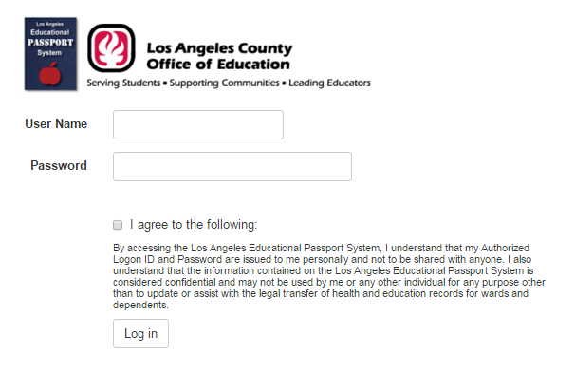
To log in, enter your user name and password, check the box to agree to the terms and conditions, and click the Log In button.

Changing your password
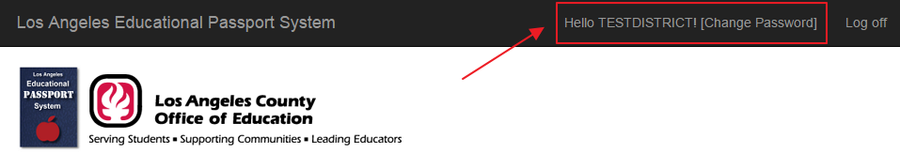
After logging in, clicking the [Change Password] link will allow you to change your password.
Note: your password must be at least 8 characters and contain at least one non-alpha numeric character (such as “#” or “!”)

Foster Youth Database
The primary application of the Los Angeles County Educational Passport System website is the Foster Youth Database.

Accessing the database
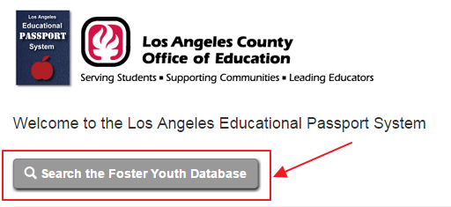
To access the Foster Youth Database, after logging into the Los Angeles County Educational Passport System website, click the Search the Foster Youth Database link.

Viewing District Students
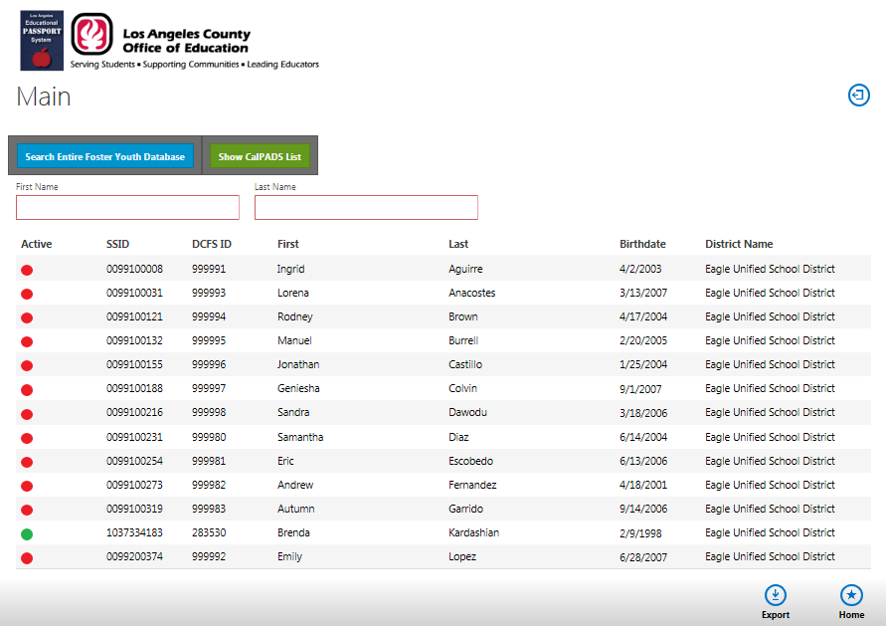
The Main screen displays all the students that are part of the districts(s) that the user has access to. This display shows active and inactive students from two sources, DCFS and LACOE. The column on the left side indicates the student’s status with DCFS. The red icons indicate students that do NOT have an active DCFS case. Green icons indicate students that currently have an active DCFS case.
To search for a student, enter a full or partial first name in the First Name box and/or a full or partial last name in the Last Name box and press the Tab or Enter key to initiate the search.
To select a student, click the row the student appears on.

Explanation of students included

DCFS
The DCFS data source shows students that are contained in the weekly Department of Children and Family Services interface that are in the district(s) that the current user has access to.

EPS
The EPS is composed of any student that has academic information that was submitted to LACOE EPS by the district(s) that the current user has access to.

CalPADS
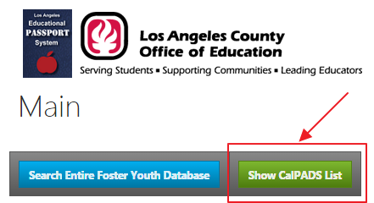
Show CalPADS list displays students that are in the district(s) that the current user has access to. The list is sortable and searchable and can be exported. Clicking on a record will display the detailed CalPADS information.
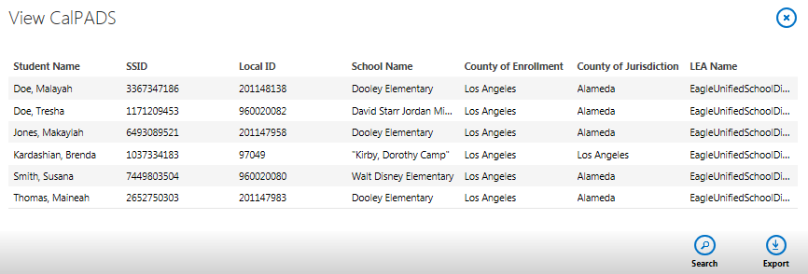

Excel Export
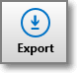
Clicking the Export button will export the entire list of students the current user has access to.

Student Detail
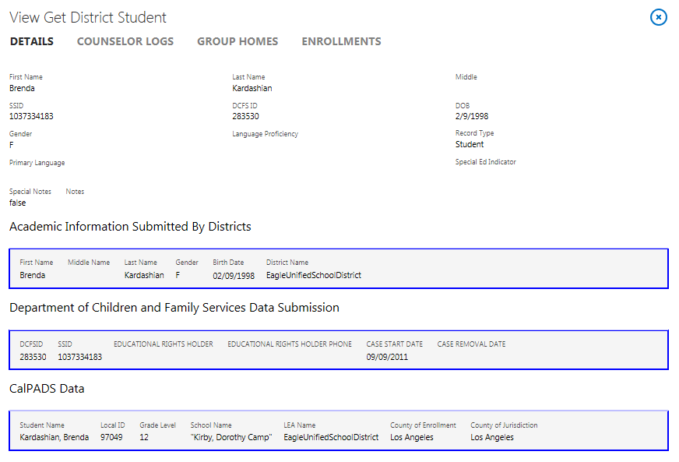
Clicking on a student on the Main screen will display detailed information for that student on the Student Detail screen.

Counselor Logs
Clicking the Counselor Log tab will navigate to the screen that will display the counselor logs entered for the student by Los Angeles County Office of Education Foster Youth counselors.

Groups Homes
Clicking the Group Homes tab will navigate to the screen that will display group home information entered for the student by Los Angeles County Office of Education Foster Youth counselors.

Enrollments
Clicking the Enrollments tab will navigate to the screen that will display all the schools that the student has attended in multiple school districts.

Academic Information Submitted By Districts
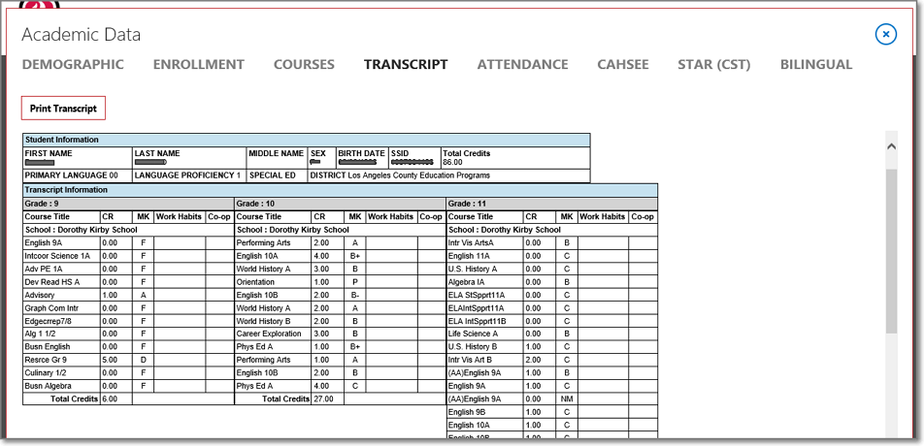
Clicking on a row under the Academic Information Submitted By Districts section on the Student Detail screen will display the academic information for the student submitted by the selected district.
- Demographic – Basic information on the student such as name, birthdate, SSID, ect.
- Enrollment – A list of all schools that the student attended in the selected district.
- Courses – A list of the current courses a student is taking at the selected district.
- Transcript – The transcript for the student at the selected district.
- Attendance – A list of attendance, by school attended, in the selected district.
- Cahsee - California High School Exit Examination results in the selected district.
- Star (CST) - Standardized Testing and Reporting results in the selected district.
- Bilingual – Language Proficiency / CELDT results in the selected district.

Department of Children and Family Services Data Submission
The Department of Children and Family Services Data Submission section contains the DCFS record(s) that the selected student is linked to. Clicking on a row in this section will navigate to a screen that will display all the DCFS data for the selected student.

CalPADS Data
The CalPADS Data section contains the related information California Longitudinal Pupil Achievement Data System. Clicking on a row will navigate to a screen that will display all the CalPADS data for the selected student.

Search Entire Foster Youth Database
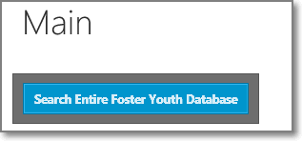
Clicking the Search Entire Foster Youth Database button on the Main screen will display the screen that will allow a user to search the entire Foster Youth database.

Performing a Search
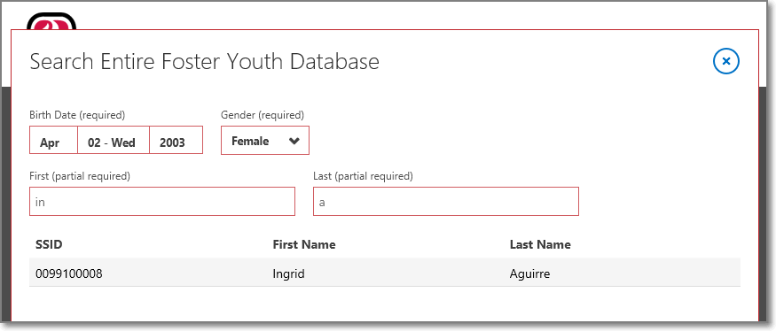
To perform a search, the following fields are required:
- Birthdate (the birthdate of the student)
- Gender (Male or Female)
- First (this can be partial, meaning it only needs to contain the first letter(s))
- Last (this can be partial, meaning it only needs to contain the first letter(s))
Pressing the Tab key or the Enter key after entering data in all the fields will perform the search. Students that match the search will display in the table. Clicking on the row the student appears in will navigate to the View Student screen (covered in the next section).

Viewing Results
Clicking on a student in the results table on the Search Entire Foster Youth Database screen will display detailed information for that student on the View Student screen.
The data displayed is identical to the Student Detail screen (covered in the previous section).

